Project Name: - Campus Navigation

A single-page web app that models a campus as an interactive graph — buildings as nodes, walkways as weighted edges — and lets users explore it, find routes, and run graph algorithms visually.
Core features
- Interactive map: Buildings are laid out on a canvas and connected by labelled paths (distance in meters), with decorative touches like an animated fountain, trees, and a sports field.
- Building info lookup: Click any building to view its department and operating hours, retrieved from the backend via HashMap-style lookups.
- Shortest path finder: Select a source and destination building to compute and visualize the shortest route between them, with total distance displayed.
- BFS visualizer: Pick a starting building to run a breadth-first search and see the traversal order and discovery-tree edges highlighted on the map.
- Admin panel: A login-gated drawer for managing the campus data — adding/removing buildings and paths, editing building info, and changing the admin password.
Architecture
- Frontend: HTML/CSS/JS, canvas-based rendering, no framework dependencies.
- Backend
- Tool/Technology | - Purpose
- Python | - Backend programming language
- Flask | - Web framework to build the backend and APIs
- SQLite | - Database to store buildings, paths, users, and building information
- sqlite3 | - Python module used to connect Flask with the SQLite database
- Hashlib (SHA-256) | - Password hashing for secure user authentication
- Heapq | - Implements Dijkstra's algorithm using a priority queue
- JSON | - Data exchange format between frontend and backend
- HTTP APIs (REST) | - Communication between the frontend and backend using GET, POST, DELETE

Tech themes it demonstrates
- Graph algorithms (BFS, shortest path/Dijkstra-style)
- HashMap-based data lookups
- Basic CRUD + auth patterns for an admin interface
- Canvas animation and interactive click-based UI
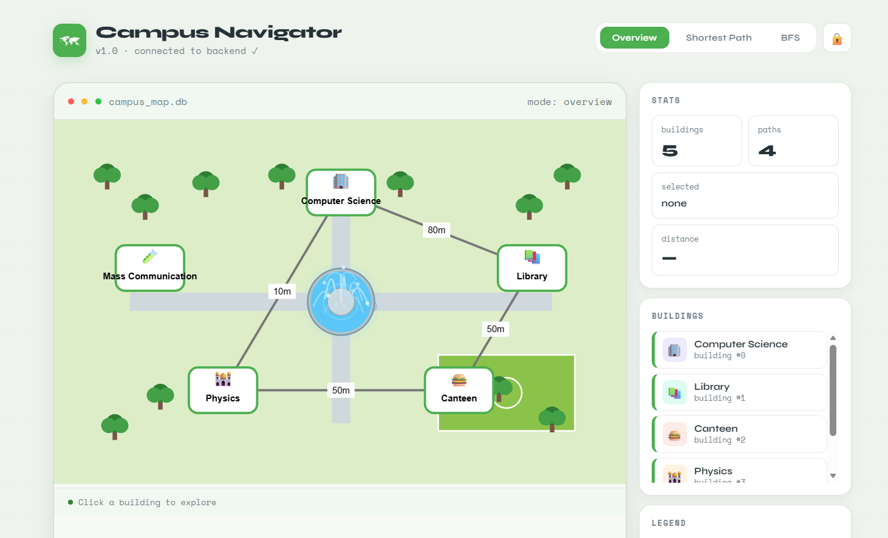
Homepage: -

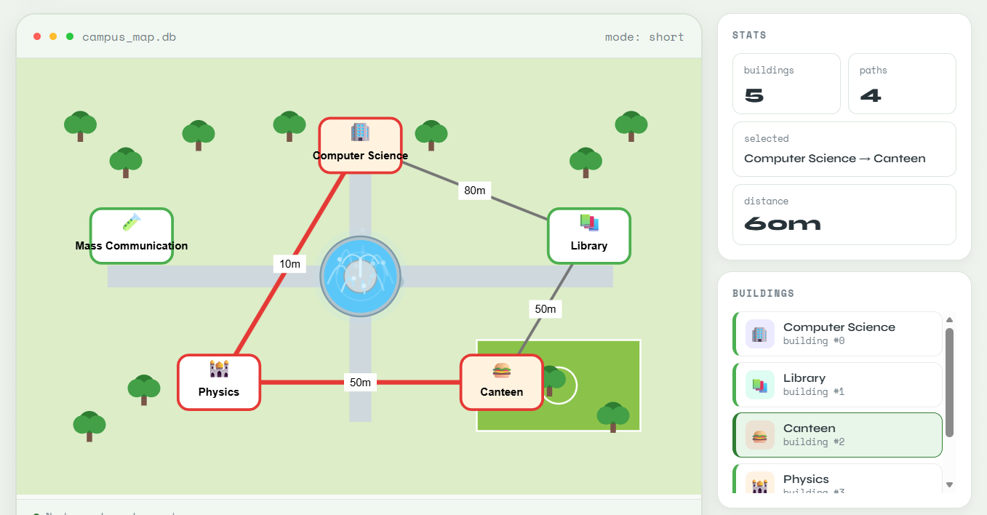
Depth-First Search Navigation: -

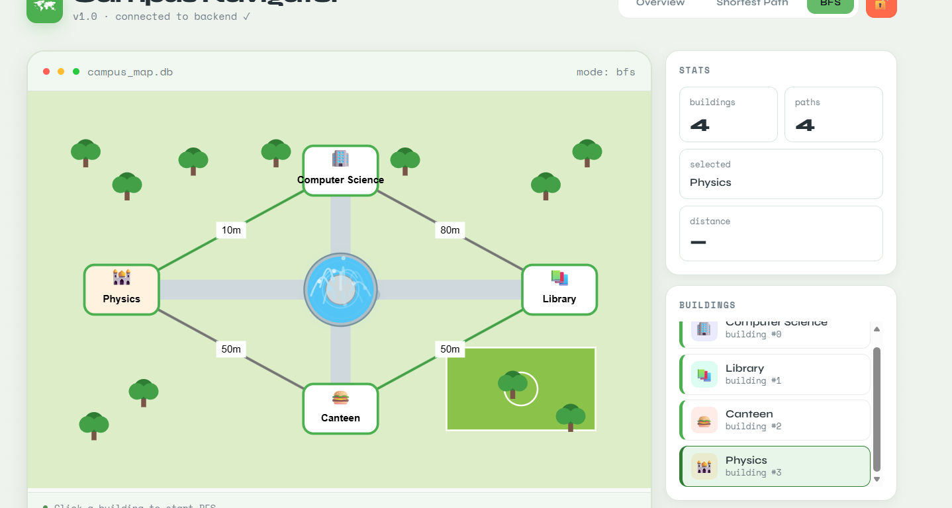
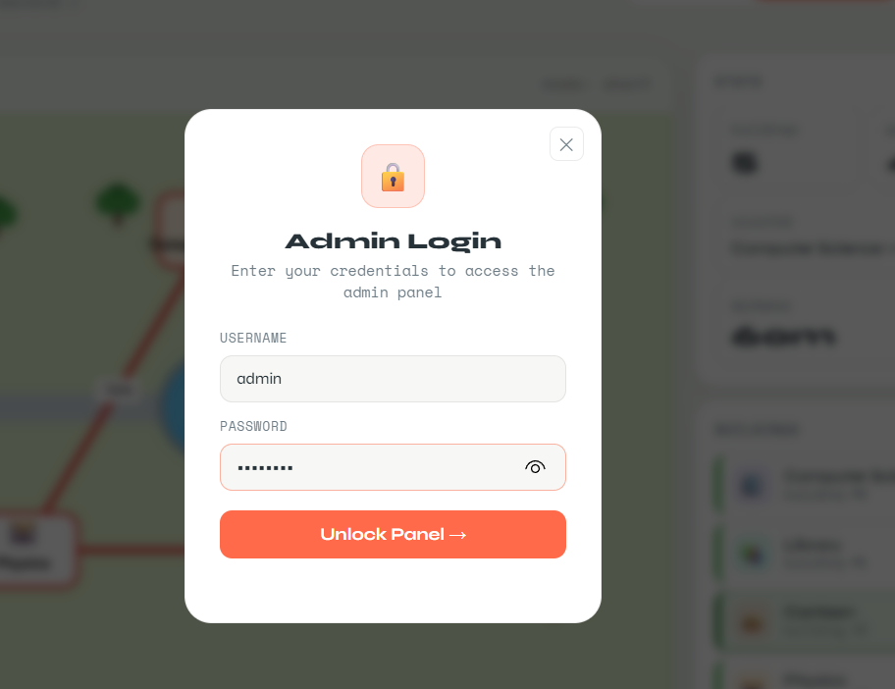

🔒 Admin Login
Breadth First Search (BFS): -
DATA STRUCTURE (DSA)
FINAL PROJECT
Name: - Hasnain Saboor
Seat No: B24110006051(CS)
Section: A
Class: 2nd Year (3rd Semester)

